GO Center Newsletter September 2017



Scholarships!

Why is this important? Even though you can apply for scholarships every day of the year, it doesn't necessarily mean you will receive funding immediately. In general, most scholarship providers take anywhere from six to 12 weeks to review applications, select winners, and disburse awards — after the deadline date has expired, not from the date you submitted your application.

**SAT & ACT & TSI**

If you are a junior or senior, you might consider taking the entrance exams in colleges and/or universities.

For seniors, the ACT, SAT, and TSI exams are critical for you to take. The earlier you have your scores, the faster you can send your official transcript to your desired university. Time is of the essence so don’t put off taking these exams until the last minute because they are crucial for your admission.

For Juniors, the exams are still required. It is important for you to start preparing for these exams now than later. Preparation is always key in receiving the best test score possible on these exams.

Need to find Me?

Office Hours:

MW 11:30am- 4:00pm

Tuesday &Thursday

9:00am- 2:30pm

-Emily Lopez

**[**REMINDERS]

[**NOV. 24-26] is the Miss Teen USA Pageant.**

[**Application Workshop]**

4:00pm to 6:00pm Every Wednesday at the Islander Welcome Center. Please bring the following.

* Updated Resume
* Letter(s) of recommendation
* Personal statement (college essay/writing sample)

Don’t wait to apply. Time goes by faster than you think and there are absolutely no exceptions for scholarships and admissions.

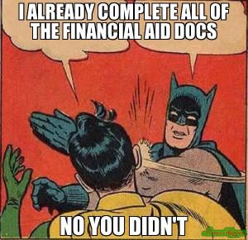



“***Education is the most powerful weapon which we can use to change the world”.***

***-Nelson Mandela***